

THE GLORION
SEPTEMBER 2026

www.gloriadeielca.com

IN CASE OF PASTORAL EMERGENCY
Contact the office during regular office hours: 9:00 a.m. – 2:00 p.m. – Monday thru Friday After office hours contact:
Rev. Tony VanCura, Pastor via phone:
407-765-2822

ADDRESS: 130 S. Lone Oak Drive, Leesburg, FL 34748

OFFICE PHONE: (352)787-3223
OFFICE EMAIL: gloriadeilutheranleesburg@gmail.com
WEB SITE: www.gloriadeielca.com
OFFICE HOURS: Monday – Friday from 9:00-2:00
PASTOR: REV. TONY VANCURA
DIRECTOR OF MUSIC: LEONARD CREMISIO
AFTER WORSHIP SEC. : JEANNE TALTS
(In order to assist the Pastor, if you need the Pastor to contact someone or address something.)
OFFICE MANAGER: EVELYN ROLLINS
SEXTON: TINA JANOSA
SUNDAY WORSHIP – 9:30 A.M

 September 2026

Being What God Wants Us to Be
As we consider what it means to be what God wants us to be, we are reminded of the new commandment God gives us: “Love your neighbor as yourself.” God calls us to love one another as we have first been loved by Him.

But what does this love look like in our daily lives? We rely upon the Holy Spirit to be our guide—to shape our words, direct our actions, and lead us forward in faith. We are called to serve, encourage, forgive, and love one another as Christ has loved us.

And yet, God also calls us to care for ourselves in a similar manner. This does not mean relying upon our own strength or abilities. Instead, we are called to allow God to provide for us and care for us. God wants us to depend upon Him rather than upon our own means.

Many of the battles and fears we face in life are struggles we carry unnecessarily. We worry about what tomorrow may bring, what we may lose, or whether we will have enough strength to face what lies ahead. Yet God has already conquered every stumbling block that stands between us and eternal life with Him. If God has given us the gift of salvation and the Holy Spirit, what
else should ultimately trouble us?

We need only to allow God to be the God of our lives and trust Him to provide all that we require. This does not mean that life will be without difficulty, but it does mean that we do not face those difficulties alone. God is with us.

Sometimes, faith means letting go. We need to let go of our fears and struggles and, instead, praise the Lord for all He has done and continues to do for us. When we do this, we discover the comfort and peace that come from knowing that God never ceases to care for His children.
Jesus gives us a beautiful image of this care when He speaks of a mother hen gathering her chicks under her wings. What a wonderful picture of God&#39;s desire to shelter, protect, and gather us close to Himself.

So, as we seek to be what God wants us to be, let us love our neighbors as ourselves, allow the Holy Spirit to guide our words and actions, and trust God to care for us as His beloved children.

God is good in all things. Thanks be to God!

PRAYERS

We will pray for the joys, sorrows, and concerns of the following members in September:

9/6 Milton and Carolyn DeLong, Judy Eads, Jerry and Julie Eld, Freddy and Marlene Farris, Claudia Fetter.

9/13 Allen and Paula Francis, Diana Frederick, James and Jayne Gable, Margi Geiger, Jackie Goding

9/20 Leone Goding, Bill Grese, Mary Grissom, Rose Gulbrandsen, Sylvia Hallberg.

9/27 Gerry Haller, Debbye Halligan, Northilt Handwerck, Dick Healy, Linda Hide.

SEPTEMBER BIRTHDAYS

9/02 Kathleen Birdsall 9/26 Crystal Kirkpatrick
9/05 Michael Clarke 9/28 Judy Eads
9/11 Richard Cassem 9/28 Mary Grissom
9/16 Deborah Cassem
9/25 Marie Davids
9/25 Quiana Menchaca

SEPTEMBER ANNIVERSARIES

9/07 Marti and Kenn Yance 58 yrs.
9/17 Chris and Karen Russell 38 yrs.
9/27 John and Janet Braun 65 yrs.

COUNCIL CORNER
Minutes of Gloria Dei Church Council Meeting
of Sunday, July 26, 2026
1. Call to order and Invocation at 11:08 a.m.
2. Roll call:
Pastor Tony VanCura |  | Chris Carlson
Dick Healy, President |  | James Menchaca
Kathy Bush, Vice President |  | Rich Cassem
Vaike O’Grady, Secretary |  | John Braun
Linda Hide, Treasurer |  | Leone Goding

3. Promise: We, elected in trust as leaders of this household of faith, are thankful for grace first given us through Jesus Christ. We agree to diligently pray for the Holy Spirit to empower us to use our gifts in mission with God to grow disciples for Christ. May all our words and deeds in this assembly and in our daily lives be examples of love, faith and peace that bear witness to God’s love for this community, the larger Church, and the world. 4. Adoption of today’s agenda—approved
5. Approval of June 28, 2026, minutes--approved
6. Executive Committee voted to support Pastor Tony’s presence at a Synod Conference on Ministry at Mission Inn, Howey in the Hills, FL from 10/5-10/7, 2026. Fees are c. $625, paid by GD.
7. Correspondence--none
8. Pastor’s report—received and reviewed; see below
9. Treasurer’s report—received and reviewed
10. Any Committee reports a. Strategic Planning Team update—minutes to be shared with Council
11. Old Business
a. Electronic entry system- Dick met salesperson 7/2 at GD. Will follow up.
b. Financial Audit job description in process by Linda Hide.
c. Church brochure printed, to be distributed—in process
d. GD disaster plan—Dianne and Pastor to meet on 8/11
e. God’s Work, Our Hands—September 13—Council supports special Leesburg Elementary donations and assembly of Personal Care Kits after Fellowship
f. Other old business
12. New business
a. NEW—replace fluorescent lights in downstairs conference room
b. Evelyn’s second anniversary at GD and proposed increase in remuneration—motion made and carried to provide a raise of $1/hour for her.
c. Sharing of Peace—changes made to service are working
d. Pet blessing (c. October 4, 2026)—moved to Saturday, Oct 3 and Vaike will meet with Pastor and others to discuss details
e. Guest presenter for congregants’ opportunity to transfer assets to GD by bequest or trust. Dick to pursue.
f. GD 75th Anniversary Celebration. Multiple times to celebrate. Start planning in October 2026 with a brainstorming session. Vaike
g. Dates of Council membership term for each current member:
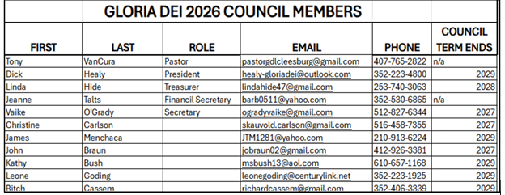
h. Other new business -- need new bulbs in the downstairs conference
13. Next Executive Committee meeting-Thursday, 8/20/2026 at 11:00 on Zoom
14. Next Council meeting- Sunday, 8/23/2026 at 11:00 in downstairs meeting room
15. Who does what? (Captured above.)
16. Benediction
17. Motion to adjourn—moved and approved 11:48 pm

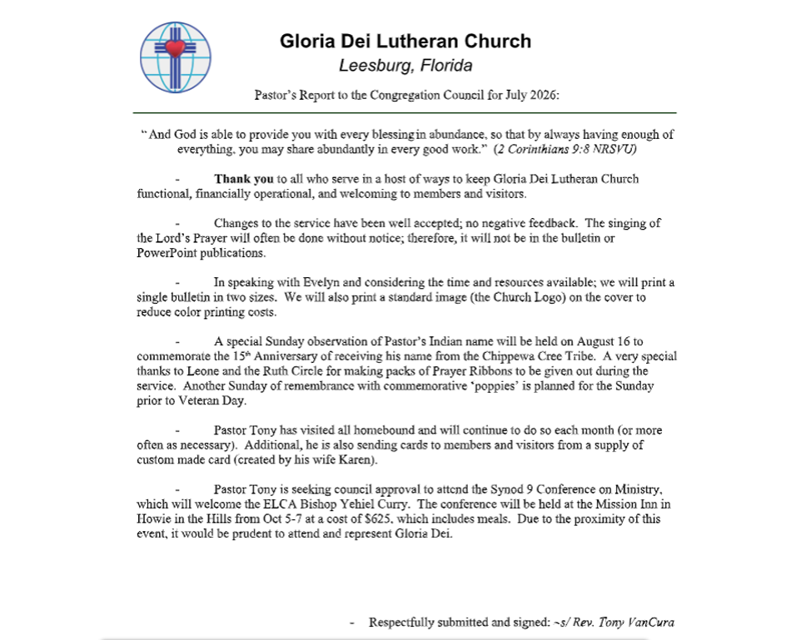

BIBLE STUDY/EDUCATION

Zoom Bible Study
During September, Pastor Tony will lead the Zoom Bible study each Monday at 7:00 p.m. with a different “scripture based” topic each week.

WELCA
WELCA stands for Women of the ELCA, which means every woman of Gloria Dei is already part of WELCA. As seasons of life change—through moves, health concerns, or aging—we have seen fewer women able to participate as actively as they once did. Even so, the heart of WELCA remains strong and welcoming. If you are able, we warmly invite you to consider becoming more involved through either the Mary Martha Circle or the Ruth Circle. If monthly meetings aren’t possible, your presence and help with projects or special gatherings are always appreciated and needed.

The Mission Statement of WELCA is “Mobilizing women to act boldly on their faith in Jesus Christ.” Our Purpose Statement further reminds us who we are and why we serve: “As a community of women created in the image of God, called to discipleship in Jesus Christ, and empowered by the Holy Spirit, we commit ourselves to grow in faith, affirm our gifts, support one another in our callings, engage in ministry and action, and promote healing and wholeness in the church, society, and the world.”
IF YOU WOULD LIKE MORE INFORMATION, PLEASE SEE LEONE, DIANNE OR LORAINE.
WELCA – Next meeting will be held on Tuesday Sept. 1st at 10:30 a.m.

RUTH CIRCLE

Next meeting will be held on Thursday Sept. 3rd at 10:30 a.m. Please bring your lunch and plan to stay for time of Fellowship.

MARY MARTHA CIRCLE

SEPTEMBER
Mary Martha Circle will meet on the 2nd Tuesday, September 8. We will
start our Mission Quilting at 9AM and have a break at 10:30. Bible Study
at 11 will be out of the Gather Magazine. We will have copies of the
lesson for anyone who needs one. We will also be Mission Quilting on
the 4th Friday, which is September 25 at 9am. Please come and join us
for fun & fellowship. Please continue to sew tops as we will continue
to need them.

Leone Goding for Carol Marshall, Leader Phone 352-787-0435

STEWARDSHIP

FALL IS UPON US
For many churches, fall is a natural season to reflect on stewardship because it often coincides with planning for the coming year. Stewardship, however, is about much more than finances—it’s about faithfully managing all God has entrusted to us.

Here are some good stewardship practices to encourage during the fall:

- Practice gratitude. As the harvest season reminds us of God’s abundance, take time each day to thank God for His blessings.
- Review your giving. Consider whether your financial giving reflects your gratitude and trust in God. Prayerfully plan your estimate of giving for the coming year.
- Share your time and talents. Fall ministries are beginning. Look for opportunities to volunteer, teach, visit homebound members, sing in the choir, or serve on a ministry team.
- Prepare for generosity. Set aside resources to help families during Thanksgiving and Christmas through food drives, gift collections, or local outreach.
- Care for God’s creation. As gardens are cleaned up and leaves begin to fall, remember that caring for the earth is an act of stewardship. Recycle, reduce waste, and appreciate the beauty of God’s creation.
- Review your priorities. Fall often brings a busier schedule. Ask whether your calendar reflects your commitment to worship, prayer, family, and service.
- Share your faith. Invite a friend, neighbor, or family member to worship, a Bible study, or a church event.
- Plan wisely. Just as farmers prepare for the next season, Christians are called to plan wisely, save responsibly, and trust God with the future.
- Tell your stewardship story. Share how God has provided for you or how giving and serving have strengthened your faith. Personal stories often encourage others more than statistics.

“Moreover, it is required of stewards that they be found trustworthy.”— 1 Corinthians 4:2

GOD’S WORK. OUR HANDS

“God’s work. Our hands” is the ELCA’s annual day of service, taking place Sept. 13,
2026. Congregations celebrate who we are as a church, engage in projects that
explore who we are as Lutherans; that all life in Jesus flows from a living, daring
confidence in God’s grace. The ELCA is one church, freed in Christ, to love and
serve our neighbor every day.

Two projects will be happening on GWOH day at Gloria Dei.

A one-time/one day in-gathering of specific cleaning items will be collected that
day to provide much needed items to the families of children at Leesburg
Elementary. This project will work as an adjunct to our “Nourish to Flourish”
program which year-round provides food to the families of children at Leesburg
Elementary. The ONLY requested items are: laundry detergent, dish soap and
trash bags.

The second project of the day will be a demonstration of how Ruth Circle
members put together Personal Care Kits to be distributed by Lutheran World
Relief. Cleanliness may not actually be next to godliness, but it certainly helps a
person feel more human. When families find their homes destroyed, or must flee for their safety, soap and a towel rarely make the cut for what they can carry. Arriving in a refugee camp or other place of safety, they are scared, vulnerable and dirty from the travel. The simple items included in a Personal Care Kit provide much needed self-care, critical germ fighting supplies and the chance for our neighbors in need to regain dignity amidst fear and uncertainty.

Lutheran World Relief distributed 231,811 Personal Care Kits
worldwide across 15 countries, including the United States.

A LITTLE SOMETHING TO ENJOY

Looking for a new puzzle? A selection is available on the shelf in the narthex— please feel free to take as many as you want and enjoy.

CALL COMMITTEE
Thank You, Thank You, Thank You!

The heart of a thriving congregation is found in the volunteers who raise their hands and say, “Yes, I’ll do what needs to be done.” Working together as a team, these dedicated volunteers have helped Gloria Dei cross the finish line once again.

From the beginning of the call process to the celebration of Pastor Tony’s installation, this journey took sixteen months. I would like to take this opportunity to thank everyone who gave their time and talents to bring us to this joyful moment.

First on my list is the Call Committee, whose members logged well over 300 combined hours throughout this process:
- Kathleen Birdsall, Chair
- Christine Carlson, Chaplain
- Linda Steege, Communications Specialist
- Dick Healy, Computer Specialist
- Pat Bressler, Member at Large
- Leone Goding, Member at Large
- Bob Pierce, Alternate Member at Large

Additional Support During the Call Process, Evelyn Rollins, Office Manager, was a blessing to the committee throughout the entire process. Although she was not a member of the committee, her skills were called upon many times over the past sixteen months.

Vaike O’Grady, Press Relations, helped ensure Gloria Dei’s presence was shared in newspapers and online.

The Congregation Council also played an important role in the process. They reviewed the
committee’s work and interviewed Pastor Tony to be sure he was the right fit for our call.

Richard Healy, President John Braun, Council Member
Kathy Bush, Vice President Christine Carlson, Council Member
Vaike O’Grady, Secretary Leone Goding, Council Member
Linda Hide, Treasurer James Menchaca, Council Member
Jeanne Talts, Financial Secretary Ritch Cassem, Council Member

For the installation service, Pastor Tony worked closely with the Synod and the Worship and Music Committee to create a beautiful service steeped in meaningful tradition. A heartfelt thank-you goes to everyone who gave their support to our new pastor.

Thank you to the following individuals and couples who shared their time and talents with planning, décor, set-up, and take-down:

Pat Bressler Linda Steege Christine and Craig Carlson
Dick Healy Leone Goding Loraine Van Haecke
Irv and Sue Johnson John and Arlene Kelly Byron and Crystal Kirkpatrick
Rich and Debbie Cassem Lillian Ostrander Marie Davis
Bill and Kathleen Birdsall

To anyone I may have missed, please accept my heartfelt apologies. It has been my pleasure to work with all of you, and I thank you deeply for sharing your time and talents to make the gift of a new pastor such a meaningful event.

It takes a flock to do the work of the church.
Kathleen Birdsall

SEPTEMBER CALENDAR
Tues. | 9/1 | 10:00 a.m. | Morning Prayer
 |  | 10:30 a.m. | WELCA Board Meeting
Thurs. | 9/3 | 10:30 a.m. | Ruth Circle
Sun. | 9/6 | 9:30 a.m. | Sunday Service/ Brief Order for Healing
Mon. | 9/7 | 7:00 p.m. | Zoom Bible Study
Tues. | 9/8 | 9:00 a.m. | Quilting
 |  | 10:00 a.m. | Morning Prayer
Fri. | 9/11 | 8:30 a.m. | Joining Hands in Food Ministry
Sun. | 9/13 | 9:30 a.m. | Sunday Service
Mon. | 9/14 | 7:00 p.m. | Zoom Bible Study
Tues. | 9/15 | 10:00 a.m. | Morning Prayer
 |  | 4:30 p.m. | Choir Rehearsal
Sun. | 9/20 | 9:30 a.m. | Sunday Service/ Hunger Offering
Mon. | 9/21 | 7:00 p.m. | Zoom Bible Study
Tues. | 9/22 | 10:00 a.m. | Morning Prayer
 |  | 4:30 p.m. | Choir Rehearsal
Fri. | 9/25 | 9:00 a.m. | Quilting
Sun. | 9/27 | 9:30 a.m. | Sunday Service
Mon. | 9/28 | 7:00 p.m. | Zoom Bible Study
Tues. | 9/29 | 10:00 a.m. | Morning Prayer
 |  | 4:30 p.m. | Choir Rehearsal

FINANCIAL CORNER
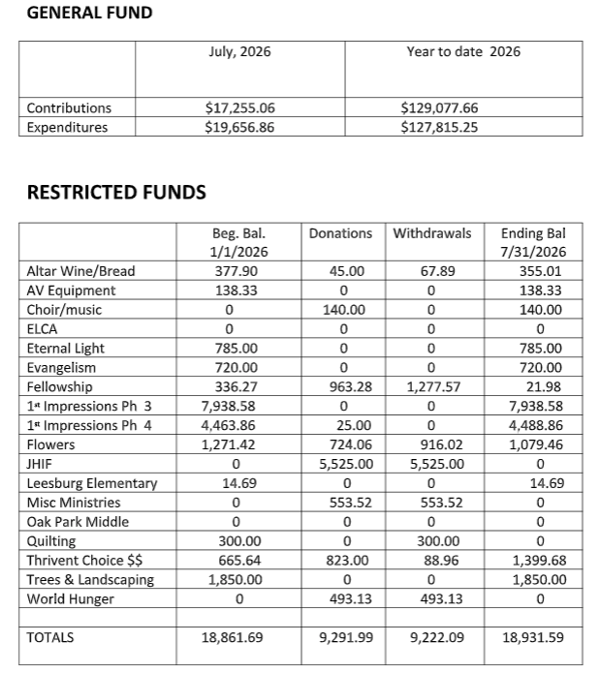

SEPTEMBER WORSHIP LEADERS
July Assistant Ministers
Legend: R-Reader, +-Crucifer, C-Communion Assist., A-Liturgy Assist.
 | 9:30 a.m.
9/6 | R= Linda Hide | 9/13 | R= Chris Russell
 | += Julian Menchaca |  | += Leone Goding
 | A=Patricia Bressler |  | A= Kathy Bush
9/20 | R= Arlene Kelly | 9/27 | R= Dianne Marcotte
 | += Leone Goding |  | += Leone Goding
 | A= Patricia Bressler |  | A= Vaike O’Grady

Ushers
If you are able to serve or have any questions, please contact Crystal Kirkpatrick at 552-3983.

 | 9:30 a.m.
9/6 | Byron Kirkpatrick | 9/13 | Byron Kirkpatrick
 | Ritch Cassem |  | Ritch Cassem
 | John Kelly |  | John Kelly
 | Craig Carlson |  | Craig Carlson
9/20 | Byron Kirkpatrick | 9/27 | Byron Kirkpatrick
 | Ritch Cassem |  | Ritch Cassem
 | John Kelly |  | John Kelly
 | Craig Carlson | Craig Carlson

Altar Guild for September: Crystal & Byron Kirkpatrick

Post Worship Secretary for September: Jeanne Talts

Fellowship
9/6
9/13 June & Jim Rieb
9/20
9/27

Counters – Tuesdays at 9:00 a.m.
9/6 | Jeanne Talts
9/13 | Linda Steege & Patricia Bressler
9/20 | Arlene Kelly & Lillian Ostrander
9/27 | Arlene Kelly & Lillian Ostrander

THE BELIEVE THE BEST PRINCIPLES

The Basics:

Every relationship has spoken and unspoken expectations. And then there are the actual experiences within the relationship. Sometimes the expectations and experiences match up, and sometimes they don’t. When they don’t it creates a gap:

EXPECTATION EXPERIENCE

gap

When a gap occurs between what we expect and what we experience, we can choose to fill the gap with one of two things:

BELIEVING THE BEST or ASSUMING THE WORST

Believing the Best is based on trust and goodwill
Assuming the Worst is based on distrust and suspicion.

Five Principles for being a “Believe the Best” community:

- When there is a gap that forms between what I expect and what I experience, I will BELIEVE the best. (We will start with trust and goodwill).

- When other people assume the worst about you, I will come to your DEFENSE.
(Gossip is not permitted; we will put the best construction on what our neighbor does- the Eighth Commandment).

- If what I experience begins to erode my TRUST, I will come directly to you about it.
(We won’t let issues fester or be shared with others, nor will we ignore them).

- When I’m convinced I will not be able to deliver on a promise, I will inform you AHEAD of time.
(We will keep our commitments to one another).

- When you confront me about the gaps I’ve created, I will tell you the TRUTH.
(We will be open to hearing others’ concerns and respond to them with integrity).

Adapted from Celebration Lutheran Church- Cypress, Texas.

2026 CHURCH COUNCIL MEMBERS
Pastor Rev. Tony VanCura 407-765-2822
President Richard Healy 352-223-4800
Vice President Kathy Bush 610-657-1168
Secretary Vaike O’Grady | 512-827-6344
Treasurer Linda Hide | 253-740-3063
Financial Secretary Jeanne Talts  Members: | 352-530-6865
John Braun | 412-926-3381
Christine Carlson | 516-458-7355
James Menchaca | 210-913-6224
Ritch Cassem | 352-406-3339
Leone Goding  COMMITTEE CHAIRPERSONS | 352-223-1925
Worship & Music Rev. Tony VanCura, Pastor | 352-249-8533
Evangelism/Technology/ Bill Birdsall  Communications | 732-773-2680
Property John Kelly | 352-399-6253
Fellowship Loraine Van Haecke | 407-252-4692
Stewardship Dianne Marcotte | 352-933-5517
WELCA Dianne Marcotte (contact only) | 352-933-5517
Christian Education Christine Carlson | 516-458-7355
Finance John Braun | 412-926-3381
Joel Weinhardt | 330-936-8451

